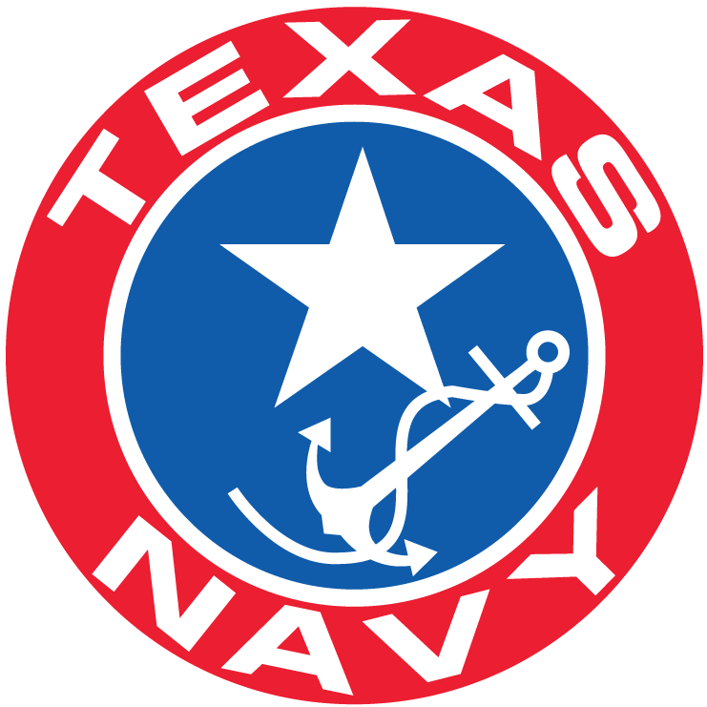

Texas Navy Association
20 April 2024
2nd Quarter Meeting of the Board of Directors
Rosenberg Library
2310 Sealy Ave
Galveston, TX 77550

- Opening of 2nd Quarter 2024 Board of Directors Meeting 12:00
Welcome to Rosenberg Library ADM Scott Powell - President

- Invocation: ADM Jimmy Peet

- Pledges:
  - USA & Texas Flags ADM Wayne Courreges Jr

- Roll Call of attending Voting Board Members ADM James Bernsen
- Confirmation of Quorum: ADM James Bernsen
- 07 January 2024 Minutes: ADM James Bernsen
- Opening Remarks: ADM Scott Powell - President

Consent Agenda

Submission to Approve and Accept the following additional TNA Members in “Good Standing” to be appointed to the listed Committees with full “Rights and Responsibilities” of the Committee according to TNA Bylaws,

ARTICLE VII

Committees

  - All committee members must be members in good standing of the Texas Navy Inc. (dba Texas Navy Association) and their appointments as members of their respective committees must be approved by the Board of Directors.

Finance Committee
ADM Jerry Patterson
ADM Ed Duffett
Education Committee
ADM Stephen Cure
Cmdr Charles Scott
Operations Committee
ADM Tom Hauser
& Suzanne Hauser

Election Committee
ADM Greg Delk
History Committee
ADM Charlie Patterson
Cmdr Sherri Driscoll
ADM Wayne Zieschang
Cmdr Michael Stack
Cmdr Malcom Johnson
Marketing Committee
ADM Rick Hawkins
ADM J Hewlett
Cmdr Simon Mcilroy
ADM John Shanahan

- Call for Motion for Consent Agenda Approval:

- Presentation of Updated Squadron Certificates

- Committee Reports:

President’s Report ADM Scott Powell
Recent Activities
Information Gathering and Meetings by TNA:
Museum of the Pacific War
USS Lexington
Texas Maritime Museum
- Committee Charges Issued

Treasurers Report ADM Kathy Howell

    - Education Committee – ADM Mariann Laughlin TNAEducation@texasnavy.com
    - Finance Committee – ADM Bob Frye
    - TNAFinance@texasnavy.com
  - History Committee – ADM Charlie Patterson
“Submittal Depository ”TNAHistory@texasnavy,com”
  - Information Technology Committee – ADM John Gross
  - Seminars Committee – ADM Bill Turner
  - Marketing Committee – ADM Rick Hawkins
“TNAMarketing@texasnavy.com”
  - Membership Committee – ADM Greg Delk
  - Ship’s Store – ADM Jerry Patterson
  - Operations Committee – ADM Wayne Courreges
Coffee Break 1:15 -1:25
“Visit the Ship Store”

Recognition Rollcall of Squadrons Attending and Visitors:
    - C. E. Hawkins
    - Chester Nimitz
    - Edwin Ward Moore
    - First Navy of Texas Squadron
    - M. B. Lamar
    - Sam Houston
    - Samuel May Williams
    - TNS Zavala
    - Tom Toby

Old Business: TNA Annual Financial “Review” timing
Need to develop and print TNA marketing brochure
Protection of TNA “Intellectual Property Rights”
Squadron Pages on TNA Webpage

New Business: Replacement of old TNA Booth Backdrop with New Donated
Motion to “Re-Home” old Booth Backdrop
  - New Admirals Presentation Commissioning
  - News Letter Publication Schedule, Focus and Submittals
  - Battleship Texas and Texas Maritime Museum Discussion
April 27 Battleship Texas Fund Raiser (Ship’s Store Attending)
  - Status of Texas Navy Rum Labelling and Distillery Partner

TNA Board Members: Open Questions & Responses, general comments
Closing: Closing Comments
Motion to Adjourn 1500
Post Adjournment
  - Viewing Texas Navy Artifacts by Rosenberg Library Museum
  - Sam Houston and Lamar Squadrons Joint Meeting and Commissioning

Dinner at Saltwater Grill ~5:30pm 2017 Post Office St, Galveston 77553
Ph: 409-762-3474

